What are three conclusions we can make about Kickstarter campaigns given the provided data?

1. Theatre was the most successful Kickstarter category but also had the most failed fundraisers as well
2. A breakdown of the subcategories of Theatre showed that plays led the way with 694 successful campaigns, followed by spaces at 85, and musicals at 60.
3. The month of May showed the highest success rate during the year, and December showed the least successful fundraiser campaigns.

What are some of the limitations of this dataset?

* We are able to view the total amount of successful/non-successful campaigns by category, but not a comparison to the category as a whole. For example, Theatre has the most successful campaigns but not the highest percent of successful campaigns. Music takes the top spot in success rate with a 77% rate as compared to 60% in theatre.

What are some other possible tables/graphs that we could create?

* A table that uses comparison of each state to the total in each comparison would be ideal to show the above comparison.

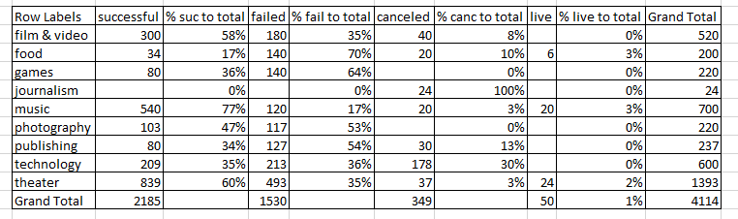

* This data could also be put into a bar/column graph to show category by success rate.
* Another data chart to look at would be total time of fundraiser for each unique ID or category. It appears that two campaigns went on for 90 days total, the highest amount, while there was 8 campaigns that latest under 5 days total. A new column could be created to show this data by subtracting date creation from date ended.